**MODULE (4) working with Database using SQL**

Que (1) statement to create the contact table

Ans;

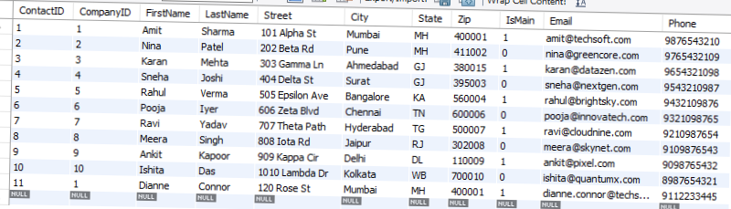

Que(2)statement to create the Employee table

Ans:

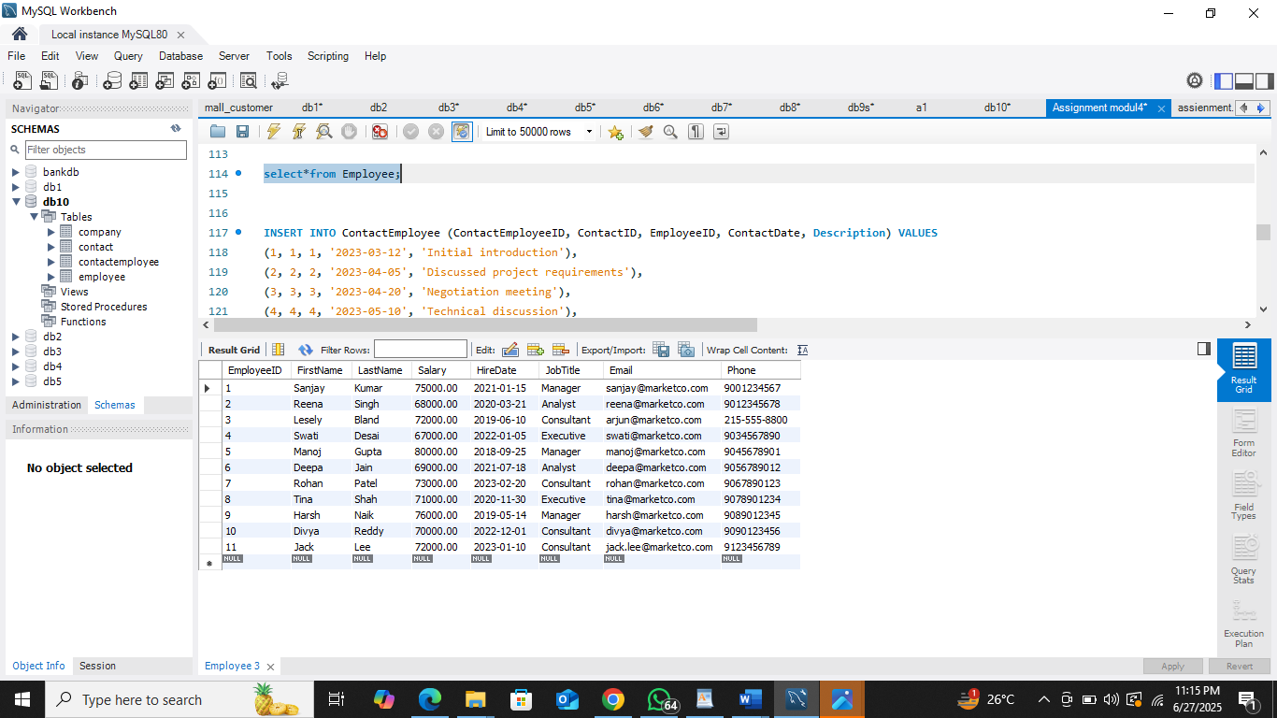

Que(3)statement to create the contactEmployee table

Ans:

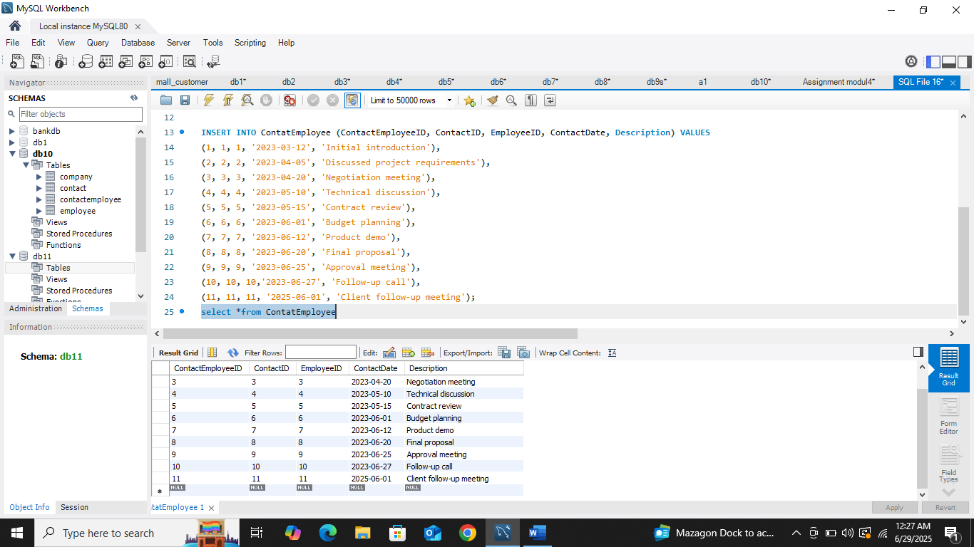

Que (4)in the Employee table,the statement that changes Lesely Bland's phone number to 215-555-8800

Ans:

**set sql_safe_updates=0;**

**update Employee**

**SET Phone = '215-555-8800'**

**WHERE FirstName= 'Lesely'AND LastName = 'Bland';**

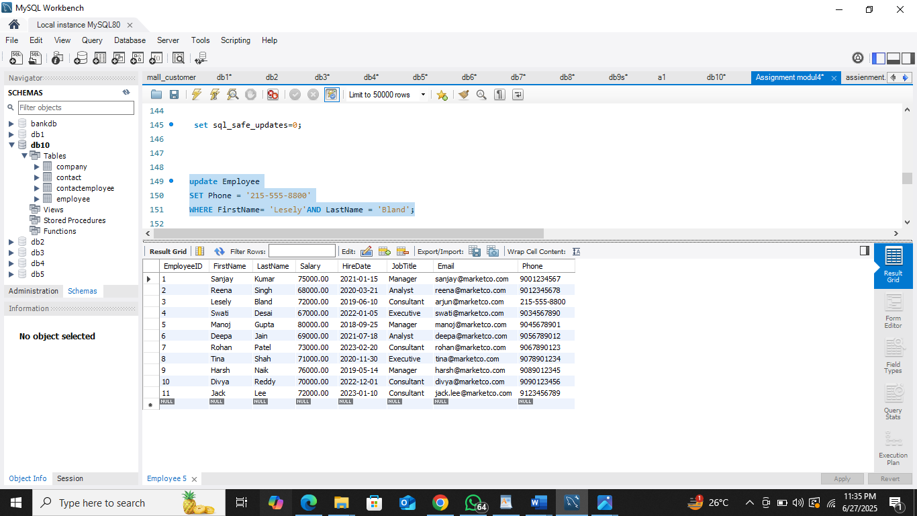

QUE (5) in the company table, the statement that changes the name of "urban outfitters,inc" to "urbaan outfiltters".

Ans:

**update Company**

**SET CompanyName = 'urbaan outfiltters'**

**WHERE CompanyName = 'Urban outfitters,inc';** 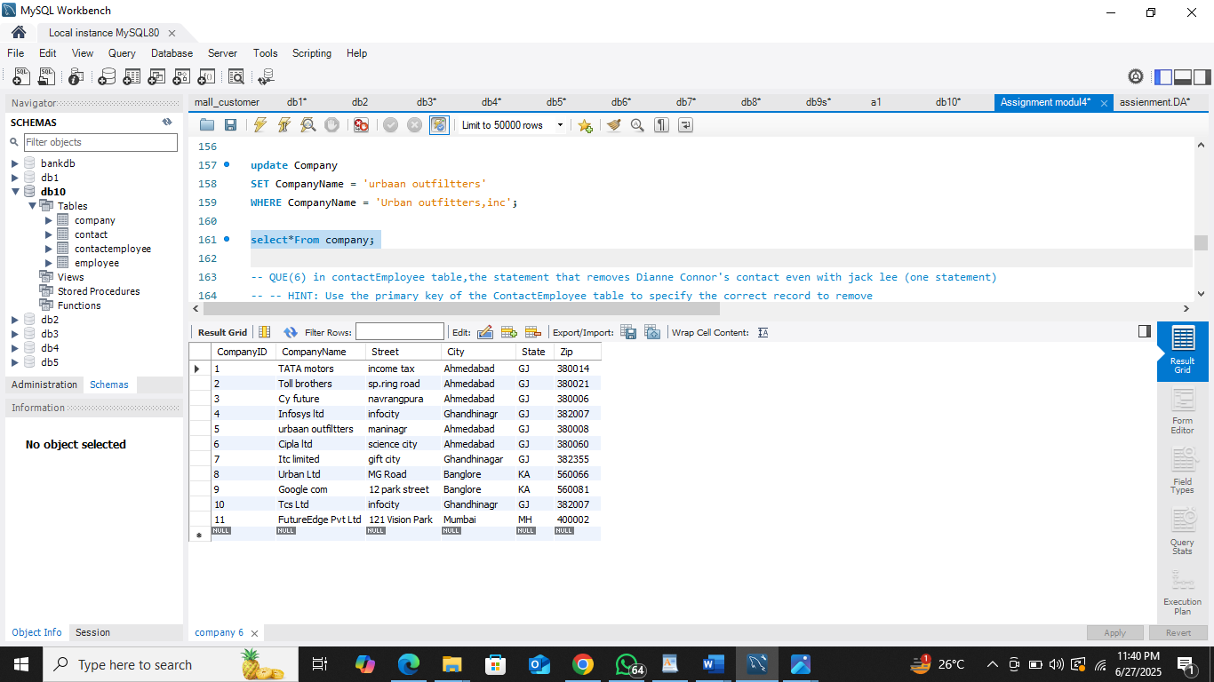

QUE(6) in contactEmployee table,the statement that removes Dianne Connor's contact even with jack lee (one statement)

HINT: Use the primary key of the ContactEmployee table to specify the correct record to remove

Ans;

**Delete ce**

**from ContactEmployee as ce**

**Join Contact as c**

**on ce.ContactID = c.ContactID**

**join Employee AS e**

**on ce.EmployeeID = e.EmployeeID**

**where c.FirstName = 'Dianne' AND C.LastName = 'Connor'**

**AND E.FirstName ='Jack' AND E.LastName = 'Lee';**

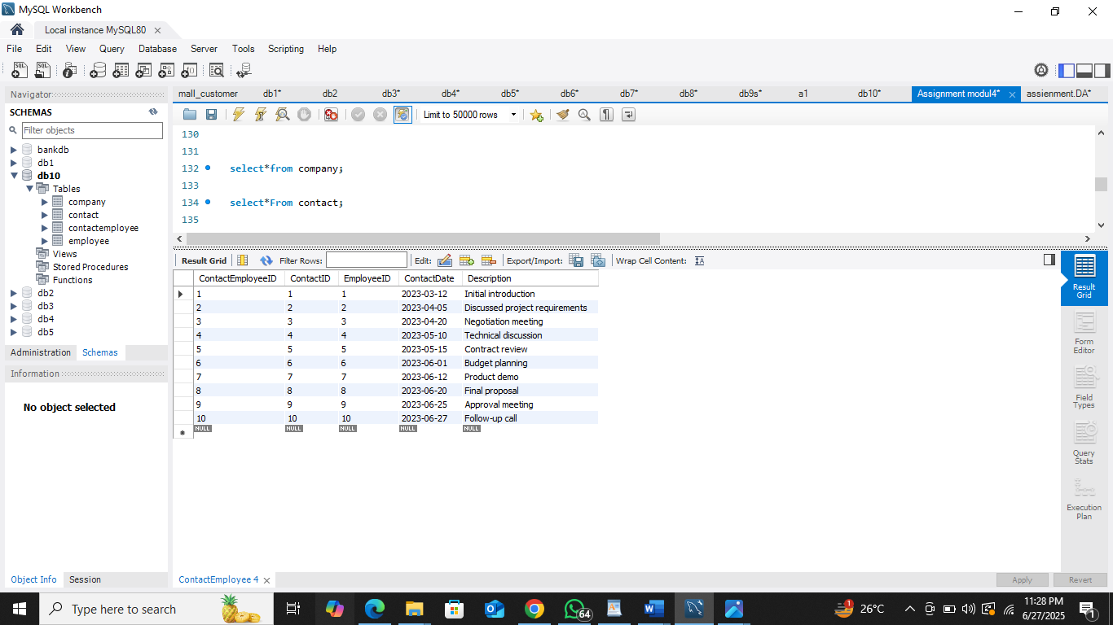

-- Que(7) write the sql select query that display the names of the employees that have contacted toll brothers(one statement) run the sql select

-- query in mysql workbench.copy the result below as well.

Ans

**SELECT e.FirstName,e.LastName,cn.CompanyName**

**from Employee as e**

**join ContactEmployee as ce**

**on ce.EmployeeID = e.EmployeeID**

**join Contact as c**

**on ce.ContactID = c.ContactID**

**join Company as cn**

**on cn.CompanyID = c.CompanyID**

**where cn.CompanyName = 'Toll brothers';**

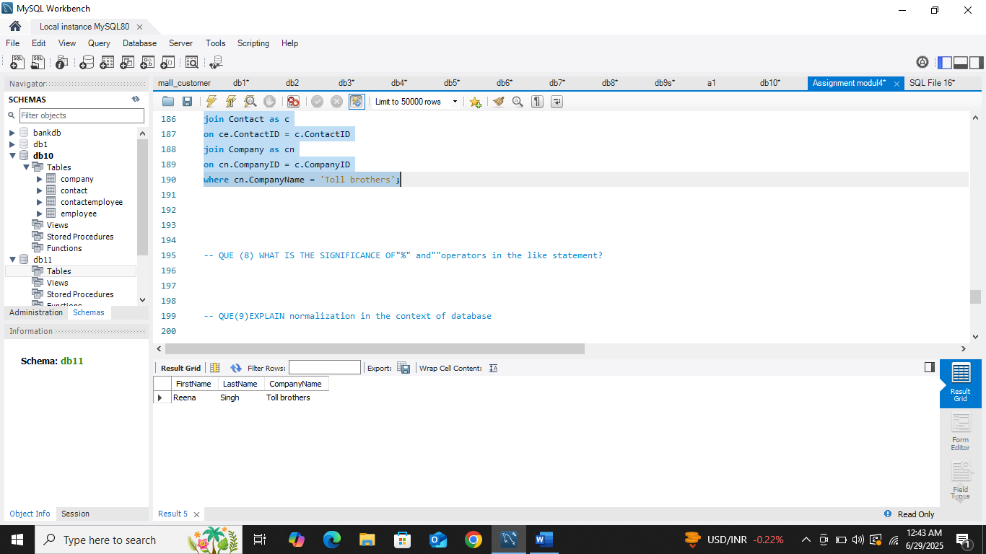

QUE (8) WHAT IS THE SIGNIFICANCE OF"%" and""operators in the like statement

Ans: In SQL the like operators is used to serach for a pattern in a column

“%” represent zero, one ,or multiple characters

‘A%’ would match any string starting with “A”.

QUE(9)EXPLAIN normalization in the context of database

Ans;normalization is the process of organization data in a database to reduce duplicate data

And improve data.

Most Commonly used normal forms:

● First normal form(1NF) ; automic values

● Second normal form(2NF) ; Partial Dependency

● Third normal form(3NF); Transitive dependency

QUE(10) what does a join in mysql mean?

ans; A join in mysql is used to combine data or rows from two or more table based on

a common field between them.

QUE(11) 19 what do you understand about DDL,DCL and DML IN MYSQL?

Ans: ● DDL–Data Definition Language

|  |  |  |
| --- | --- | --- |
| * CREATE | * Create | * Creates a new table, view, or other database object |
| * ALTER | * Modify | * Changes the structure of an existing table |
| * DROP | * Delete | * Deletes a table or object from the database |

● DCL–Data Control Language

|  |  |  |
| --- | --- | --- |
| * GRANT | * Allow | * Gives permissions to users |
| * REVOKE | * Deny | * Removes previously given permissions |

DML – Data Manipulation Language

|  |  |  |
| --- | --- | --- |
| * INSERT | * Add | * Adds new data (rows) into a table |
| * UPDATE | * Change | * Updates existing data in a table |
| * DELETE | * Remove | * Removes data (rows) from a table |

QUE(12) what is the role of the MYSQL join clause in a query,and what are some

common types of joins?

Ans; A sql join statement is used to combine data or rows from two or more table based on

a common field between them.

there are many common types of join inner join ,left join,right join,full join or full outer join

cross join and self join.